1. **NOTE**: Each time, a user makes a request, he/she has to send credentials to authenticate means we don’t have still sign-in feature in RESTful API.  
   With sign-in feature, the user will send credentials only once to the sign-in REST API and it will return token and that token will be exchanged in all subsequent requests as authenticated user.
2. **Agenda**:
   1. Creating Sign-in or Login REST API.
3. Steps:
   1. 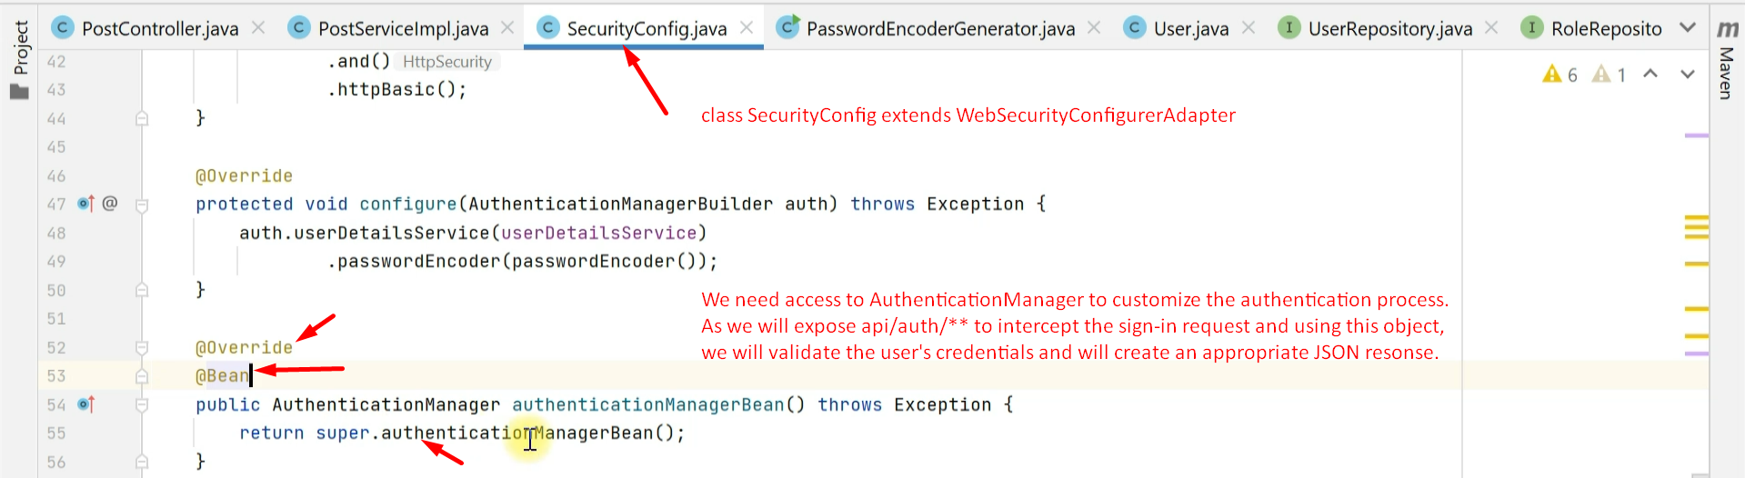
   2. 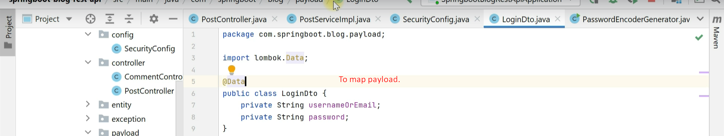
   3. 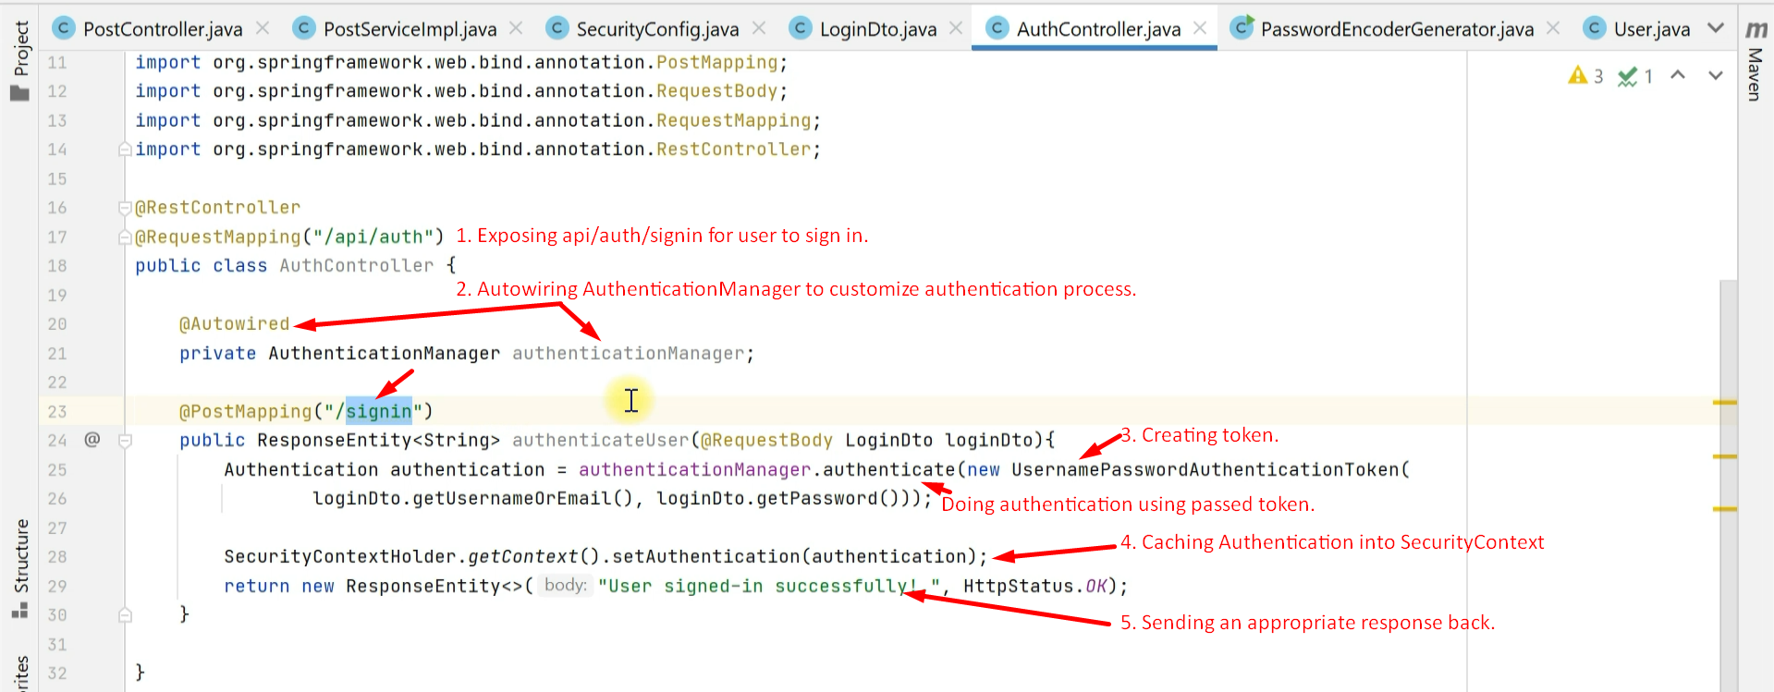
   4. 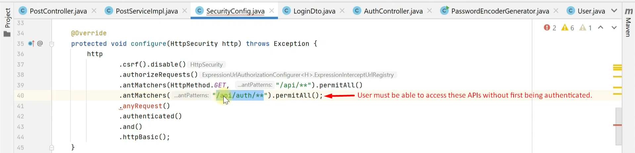
   5. Testing:  
      